Name ___________________________

Eclipsing Binaries
Using the Eclipsing Binary Stars Applet at
http://astro.unl.edu/naap/ebs/animations/ebs.html

Binary star systems in which the two stars are close enough to block each other’s light are called eclipsing binaries. You have already been introduced to the eclipsing binary star program that is on the desktop of each computer in this room. Today you’re invited to have some fun with that program, and identify certain types of eclipsing binaries.

First answer the three questions about the light curves seen below.

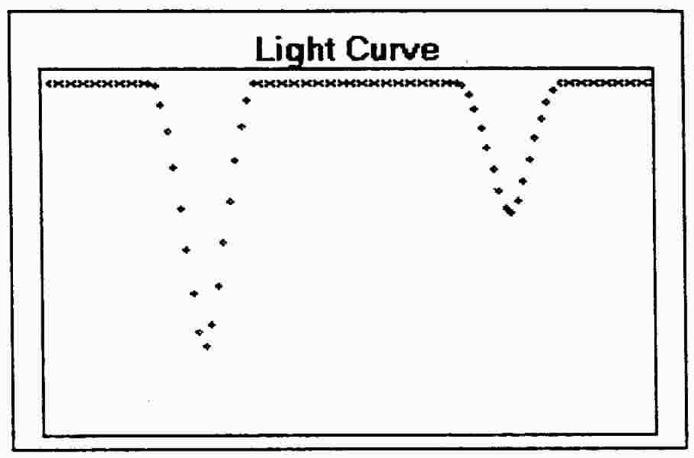
1. How does one arrive at a light curve for a binary system that looks like the one on the right?

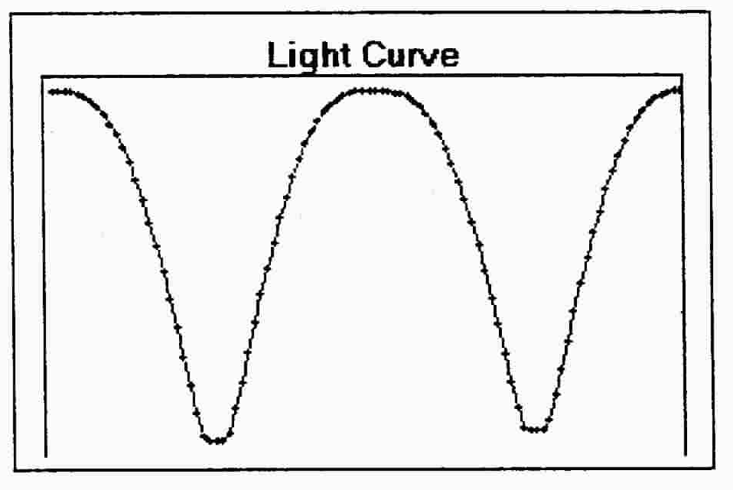
2. What conditions of size and luminosity are necessary to create this light curve?

3. Try to arrange the characteristics of your two stars in order to get the light curve seen at the right. When you are successful, describe the sizes and luminosities of the two stars.
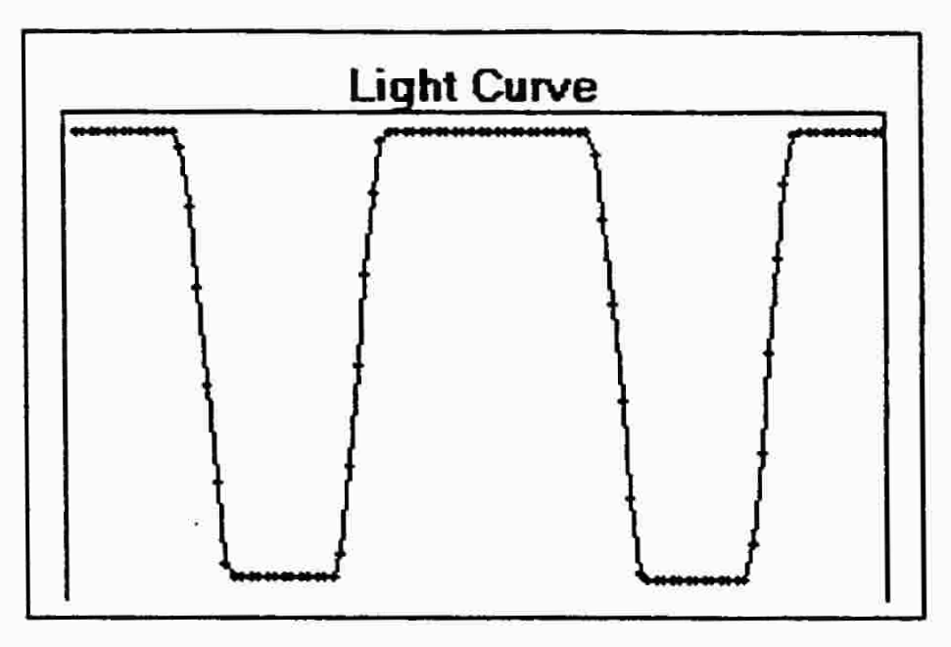

Now alter your two stars characteristics in order to answer the following questions.

4. Set the two stars to be both of spectral type A. At what orbital inclination will eclipses not occur? Record the separation.

5. Make one star type G. Make the other type M. Both stars will now orbit around a common center of mass. How many times closer is the G star to the center of mass?

6. How does having two stars of different spectral type affect the light curve? Give an example.

7. Increase the separation to maximum. Describe the type of eclipses you see when both stars are of type M.
Finally, invent four other eclipsing binary systems, record all of the characteristics such as size and luminosity and sketch light curves of each of your four different systems below.

