Solar Rotation

When one observes the Sun over a period of several days, it becomes apparent that the Sun rotates on its axis. We can measure the period of rotation of the Sun to a high degree of accuracy by measuring the changing position of sunspots across the face of the Sun.
The NASA SOHO website has a vast archive of white light images of the Sun. There is a link below today's image of the Sun that takes you to a 'list of all available daily images'. You will have to search through the long list of archived images of the Sun near the time of the last solar maximum. You will find some excellent spots starting in the middle of the month of February of the current year, 2024.
In this lab exercise, you will measure sunspots for ten different days, enter the data in an Excel spreadsheet, and allow Excel to make a graph of the results. The trendlines on that graph, will give you the slope of three different lines on that graph, allowing you to determine the solar rotation period. This will be the synodic rotation, seen from our vantage point on the moving Earth, not the sidereal rotation.

Here's how to make the measurements needed to determine the period of rotation. Go to the website seen above to begin on your chosen first day. First you must be sure to measure the same spot on all of the images. This become easy since the sunspots are numbered on these images. Sunspots can change their appearance slightly over a matter of days. You will need to make two measurements of each spot on each day. Refer to the diagram below.
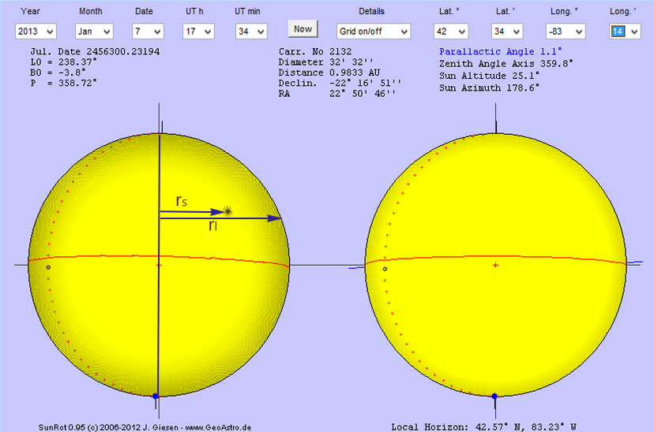

The first measurement, rs, is the distance from the meridian to the spot itself. It will be positive or negative. The second measurement, rl, is the distance from the meridian, through the spot, to the limb.
Put your results for one spot in the appropriate column on the Excel file. Now choose a completely different sunspot and put those measurements in the column labeled spot 2.
Do the same for the third spot.

You will notice that r1 should be constant for each of your three spots. Enter r_{l} for each spot in the appropriate yellow highlighted cell at the bottom of the spreadsheet. Be sure to enter rs as a negative number if it is to the left of the meridian and a positive number if it is to the right of the meridian. In the spreadsheet, notice that the angle will be some number between -90° and +90°, depending on whether the spot is to the left or the right of the meridian. This angle will be the inverse sine of rs/rl. Excel will calculate that angle for you.

By the way, choose your three spots so that they persist for the entire ten day period. What happens if one of your spots disappears before the seven day interval is over?

Name

Sunspot Position vs. Time

Insert your graph, created by Excel, here.

Questions:
- Your trendlines for the three spots should have similar slopes. What is the average of the three slopes of your lines? The units of your slope should be degrees per day.

- The reciprocal of your answer to question 1 times 360 degrees will give you the rotation period of the Sun. What is your value for the synodic period of rotation of the Sun? Use your data to show how you got the answer. You may find the accepted value for the rotation online. Calculate the percent error of your answer.

$$\% error = \frac{your value-accepted value}{accepted value} ∙100\%$$

Add this page after completing it to the appropriate tab in OneNote to complete your assignment
name your file this way: sunlablastname.docx

