Spectroscopy

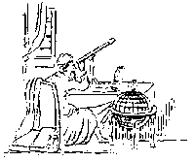

Kirchoff's Laws

In the eighteenth century, scientists learned that it was possible to break ordinary light in to its component colors. We see this effect as a rainbow whenever there are tiny droplets of water in the sky. This rainbow of colors is most properly called a spectrum. What was not realized, at first, was that there are different types of spectra. In the nineteenth century, Gustav Kirchoff described three different types of spectra. Each type is created under a different set of circumstances.

* ***A continuous spectrum is the result of a solid or high-pressure gas, which has been heated to a high temperature.***
* ***A bright line spectrum is caused by a low pressure gas which is also at a high temperature***
* ***An Absorption spectrum is seen when a lower temperature, dense gas is placed in front of a source of a continuous spectrum.***

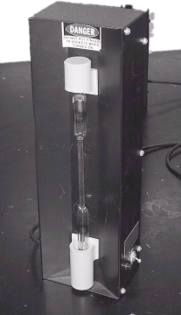

In this lab exercise, you will observe all three of these types of spectra. First you will observe emission spectra produced by gas discharge tubes. The tubes are made to glow by putting a large voltage difference across the two ends. To the right you see an image of one of the power supplies we will use. Be very careful with these power supplies. The high voltage could be very dangerous. You will find the tubes you need already mounted in the power supplies. All you need to do is plug them in and turn them on.



You have already used the Project Star spectroscopes. Remember that the light must pass through the vertical slit on the top right side of the spectroscope. You may want to get as close as you can to each discharge tube to get the brightest image possible. If you look through the spectroscope properly, you will see the spectrum overlapping the scale on the left of your field of view. the units are in nanometers, or billionths of a meter, and give you the wavelength of each color.

First, you should look at a continuous spectrum. We can all do this as a group all at once. We have a rheostat set up so that we can vary the voltage to an incandescent bulb. You see the rheostat and bulb to the right.

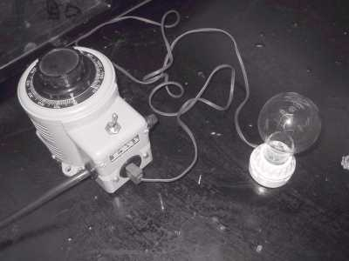

In order to vary the voltage, we will turn the dial on the top of the rheostat starting at zero.

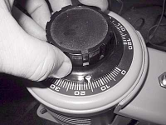

Look through the spectroscope as the voltage is increased. The mix of colors should change as we turn up the voltage, causing the filament of the bulb to get hotter.

What is the first color that you can see? What colors are missing at first?

_________________________________________________________________

Describe the mix of colors seen in the spectrum as the voltage is turned up to maximum.

____________________________________________________

What type of spectrum are you seeing?

___________________________________________________________

Record the wavelengths of the following colors:

Red ___________ Yellow ____________ Green ____________ Blue ____________ Now go from station to station, recording the positions of the bright lines you see in the three gasses shown below. Try to be precise in your drawings. The wavelengths listed on you spectroscope might be of help.

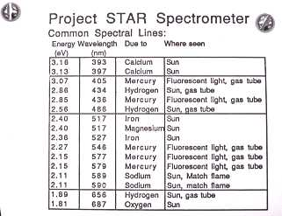



Neon is hard because there will be a ***lot*** of lines, be patient and do your best.

Look at the fluorescent light panels in the ceiling of the lab. Carefully draw what you see below.



From what you have observed with your other gasses, what type of gas might be found inside fluorescent lights?

_____________________________________

Now draw two other gasses of your choice.

Be sure to identify each gas on your two drawings.





Now look at the solar spectrum



What type of spectrum does the Sun produce?

____________________________________

As you finish this lab, there is only one more thing that you need to do

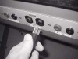

UNPLUG EVERYTHING!