Name ____________________

Stellar Properties using the H-R Diagram

About one hundred years ago, two individuals had the idea to plot two easily determined characteristics of stars in order to see what pattern might be revealed. The result is what we call the Hertzsprung-Russell diagram, or H-R diagram for short.

In this lab exercise, you will use the interactive application at

http://astro.unl.edu/naap/hr/animations/hr.html

to determine some of the properties of some well-known stars as well as some notable nearby stars. You will also discover some of the important regions on an H-R diagram. There is a link to this site on Carpe Caelum.

The illustration below shows you the start screen for the application. You will find several controls on the screen as you run this simulation. We will not use most of them, at least at first. Note that you can enter values for the temperature and luminosity of a star, and it will display the star's position on the H-R diagram for you.

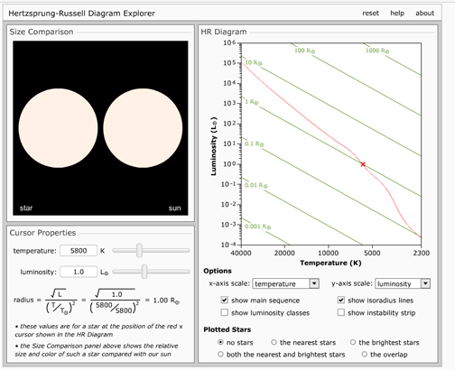

Let's first take a look at two distinct groups of stars.

The first will be those stars which make up our constellations, in other words, the fifty or so brightest stars in our night sky. Click the appropriate button on the simulation to show only those stars. Your screen should now appear as in the illustration to the right.
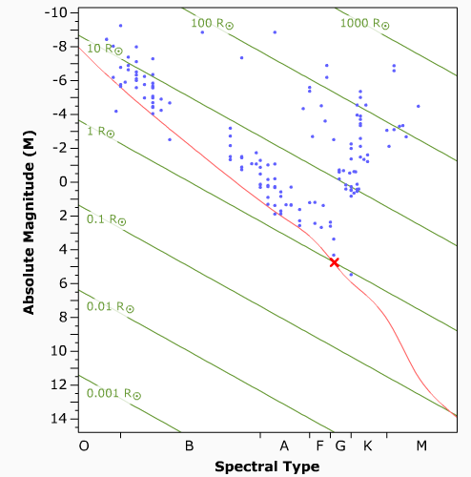

What range of absolute magnitudes do these stars represent?

What luminosity classes are the majority of these bright stars?

Now select those stars in our immediate neighborhood. That is, those nearby stars within ten parsecs or so. You should see something similar to the image to the right.
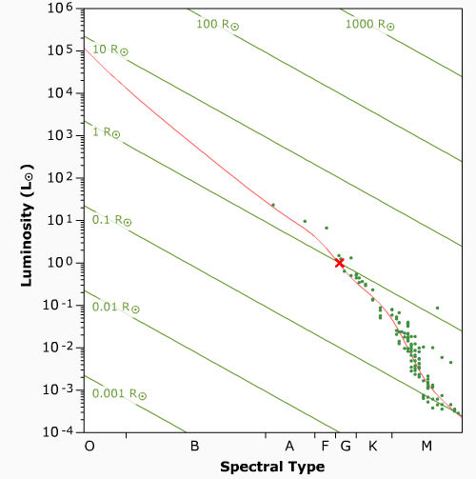

What is the predominate spectral type for these nearby stars?

What range of surface temperatures do we see?

The table on this page will give you a list of stars that we will plot on the diagram. You will need to fill in the last two columns by setting the simulation for the correct temperature and luminosity, and then reading the other values off the screen.

DATA TABLE 1
Star Name | Surface temperature | Luminosity L_{SUN} | Spectral Type | Radius R
Sirius A | 8860 | 24.2
Sirius B | 25200 | 0.056
Vega | 9602 | 40.12
Canopus | 7350 | 15100
Rigel | 12100 | 120000
Regulus | 12460 | 288
Deneb | 8525 | 196000
Arcturus | 4286 | 170
Barnard's Star | 3340 | 0.00311
Wolf 359 | 2500 | 0.00093
Alpha Centauri A | 5720 | 1.56
Alpha Centauri B | 5080 | 0.555
Zubenelgenubi | 6745 | 38
61 Cygni A | 4526 | 0.153
61 Cygni B | 4077 | 0.085
Epsilon Eridani | 5084 | 0.34
Betelgeuse | 3390 | 120000

You will have to change the x-axis scale in order to get the spectral type. The radius of each star will be calculated for you. You may wish to turn the isoradius lines on so you can estimate the sizes of all of these stars in terms of the Sun's radius. The radius of the Sun is given as R

The first star you do will be Sirius, the brightest star in our night sky. Sirius is actually a binary star system.

How many times larger is Sirius A than our Sun? _____________

How many times smaller is Sirius B? _____________

What is the spectral type of Sirius A? _____________

What is the size of Deneb compared to the Sun? ________________________

Why are we so interested in 61 Cygni as a place to look for Earth-like planets in our neighborhood of the galaxy?

(where is it on the diagram?) _________________________________________________

Which other stars from the list are nearly the same type as the Sun? ___________________________

___________________________

How many times larger than the Sun is Arcturus? __________________

What is the spectral type of Arcturus? ____________________

Now plot a star with the following characteristics. Set the temperature at 8000 K and the luminosity at 10000 times the Sun's brightness.

What kind of star do you have? In what region of the H-R diagram do you find it?

__________________________________________________

Of all of the stars you plotted on the diagram, which is the largest? __________________

Which star was the smallest? ___________________

Luminosity classes separate the stars generally by size. Three types can be made to show up on the diagram. They are indicated by Roman numerals. Which of the stars in the table are in the following luminosity classes?

I (supergiants) _________________________________________________________

III (giants) _________________________________________________________

V (dwarfs) _________________________________________________________

