Three Types of Spectra

Kirchoff's Laws

In the eighteenth century, scientists learned that it was possible to break ordinary light in to its component colors. We see this effect as a rainbow whenever there are tiny droplets of water in the sky. This rainbow of colors is most properly called a spectrum. What was not realized, at first, was that there are different types of spectra. In the nineteenth century, Gustav Kirchoff described three different types of spectra. Each type is created under a different set of circumstances.

- A continuous spectrum is the result of a solid or high-pressure gas, which has been heated to a high temperature.

- A bright line spectrum is caused by a low pressure gas which is also at a high temperature

- An Absorption spectrum is seen when a lower temperature, dense gas is placed in front of a source of a continuous spectrum.

In this lab exercise, you will observe all three of these types of spectra. You will do this by going to the University of Nebraska website at

https://astro.unl.edu/classaction/animations/light/spectrum010.html

You can go to this page by right-clicking on the link.

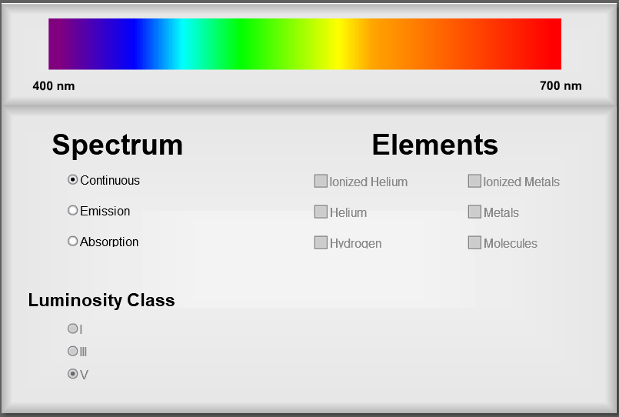
The animation starts with the view to the right.

First, you should look at a continuous spectrum. Notice a couple of things about this spectrum. Reading from right to left, you see the familiar sequence of ROYGBIV. You'll also see the wavelengths of the different colors in nanometers.

What is your best estimate of the wavelength of yellow-green light?

Next, click the radio button to show an emission spectrum. The image starts off being black, of course, because you have not selected any elements yet. Let's start with hydrogen. You should see the first five lines of the visible light spectrum of hydrogen. You should see these colors as red, blue-green, blue, and two violet lines.
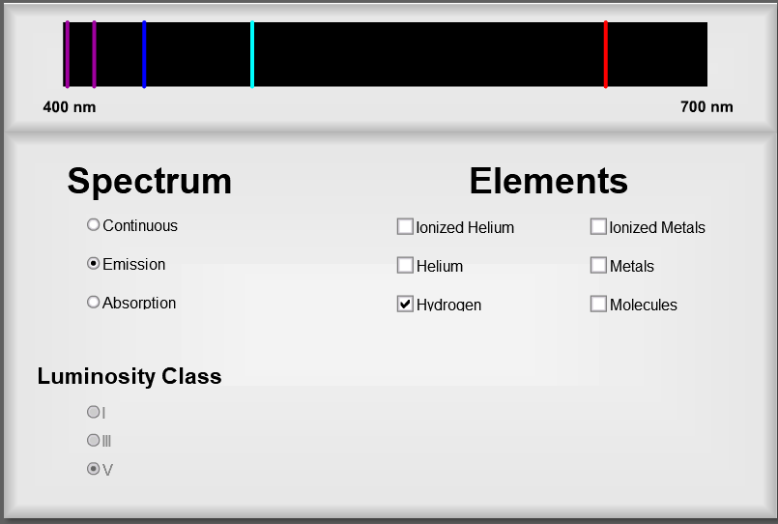
What is the name of this series of lines and what are the individual names we use for the red, blue-green and blue lines?

Any idea of why these hydrogen lines are so few in number?

How is the spectrum of helium different for the spectrum for hydrogen?
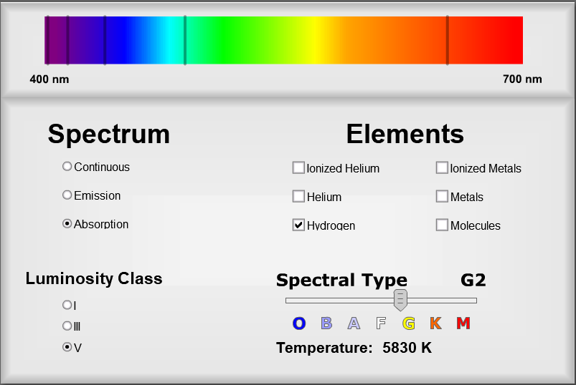
Now let's move on to some stellar spectra. For this, you will need to select the absorption spectrum button.
Notice that the slider for stellar type becomes active now. The sequence for stellar spectral types, hottest to coolest, goes through the seven letter sequence O B A F G K M The slider starts at the Sun, which is a spectral type G2. You will also note that I have checked the square to show the hydrogen lines.

By moving the slider to different spectral types, you'll be able to answer the following question.

In which spectral type is the Balmer Series most distinct?

Note the changing temperature for the different spectral types. You also have seen that the seven spectral types are sub-divided by number.

Which spectral type has the highest surface temperature, and what is that temperature?
What must the spectral type of a star be in order to see the absorption lines due to helium?

For astronomers, metals include just about every other element on the periodic table that is neither hydrogen or helium. Select the square to show metals.
For which spectral type do the metals appear most prominently?

You live on a planet that is made primarily of metal. It certainly has a large iron core. Since stars and their surrounding planets are though to be made of pretty much the same mix of elements, what does this say about where we might expect to find Earth-like planets in our Milky Way galaxy?

Finally, check the rest of the boxes in turn and see how those other elements are either present or absent in different spectral types. Pay particular attention to the molecules. They are generally prominent in only one spectral type of star.
What is it about the one spectral type where metals are prominent that make that an expected observation?

