Name ________________________________
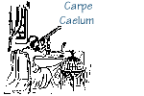

Visual Binaries Lab

Visual binaries are just one of the many types of binary star systems that we have studied. In a visual binary system, two separate stars are observed orbiting each other over a fairly long period of time. In this laboratory exercise, you are given be orbital plots of ten different binary systems. Note that every one of the orbits appears to be an ellipse. But the true shape of the orbit can be affected by tilt of the orbit.
Notice two other things about the orbital plots. The position angle is indicated, a number between zero and three hundred sixty degrees which indicates the direction to be secondary star of the system. Also notice the scale in seconds of arc on each orbital plot.
Answer the following questions about the orbits of the ten visual binaries that are found within this lab exercise.

1. Periastron is the point in a binary star orbit where the two stars are closest to each other. Refer to the orbit of Alpha Canis Majoris, otherwise known as Sirius. In what year will Sirius reach periastron?

2. 61 Cygni consists of two stars very much like the Sun. Describe the separation of these two stars in the current year, 2011

3. Alpha Centauri, the star closest to the Sun, is actually two stars. What is the average separation, in seconds of arc, of these two stars? Make this calculation by measuring the long dimension of the ellipse and dividing by two.

4. Which star system has the longest orbital period?

5. If you know anything at all about ellipses, you know of the point in an ellipse called the focus. From that information, which of the 10 binary systems has the greatest tilt to its orbit?

6. Which of the binaries has the greatest separation in the current year? How many seconds of arc is that separation?

7. Can you tell from the orbital diagrams which systems have the secondary star moving toward the Earth? If not, how would astronomers be able to determine this?

8. Can you tell which of the binary star systems would show the smallest Doppler shift in 2011?
Sirius 61 Cygni
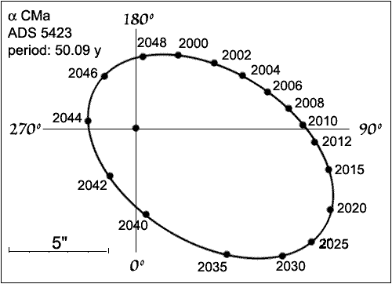
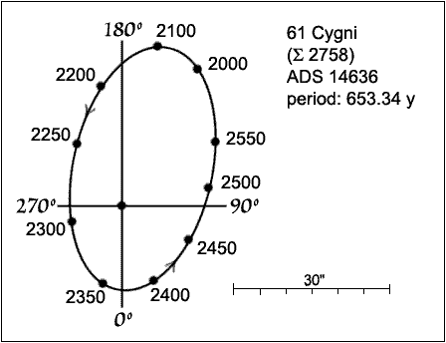

α Centauri Castor
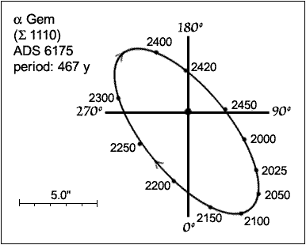
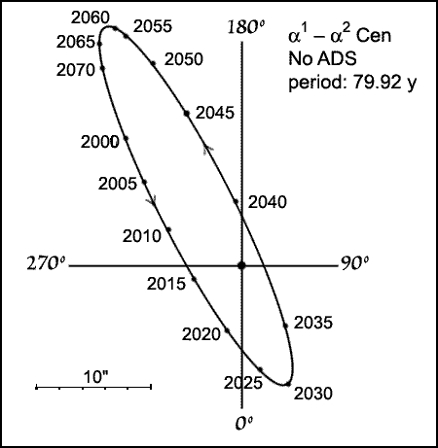

70 Ophiuchi
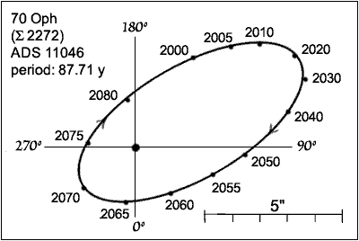

ξ Ursae Marjoris γ Virginis
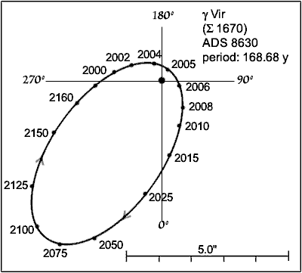

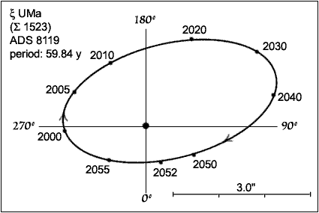

α Canis Minoris Groombridge 34
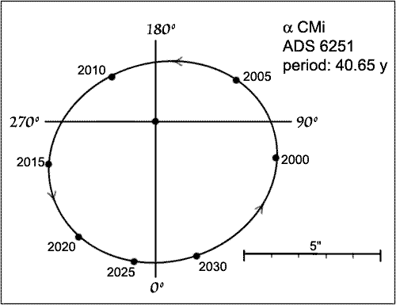
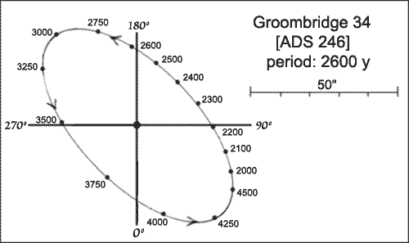

Σ 1909

